Reynold’s Middle School
August 18, 2014

Download a QR reader on you smart phone or iPad and locate these resources anywhere! All images are also hyperlinked.
BCS – ELA  Instructional Framework | 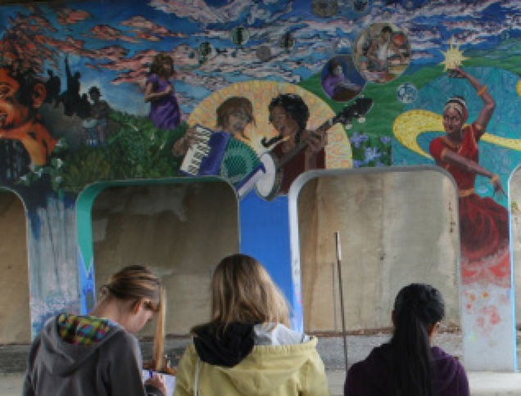  Instructional Framework | 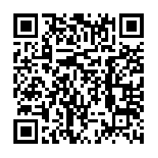
BCS Instructional Framework  Resources | Instructional Framework  Resources | 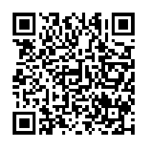
Dr. Martin Luther King, Jr.  Thinglink | 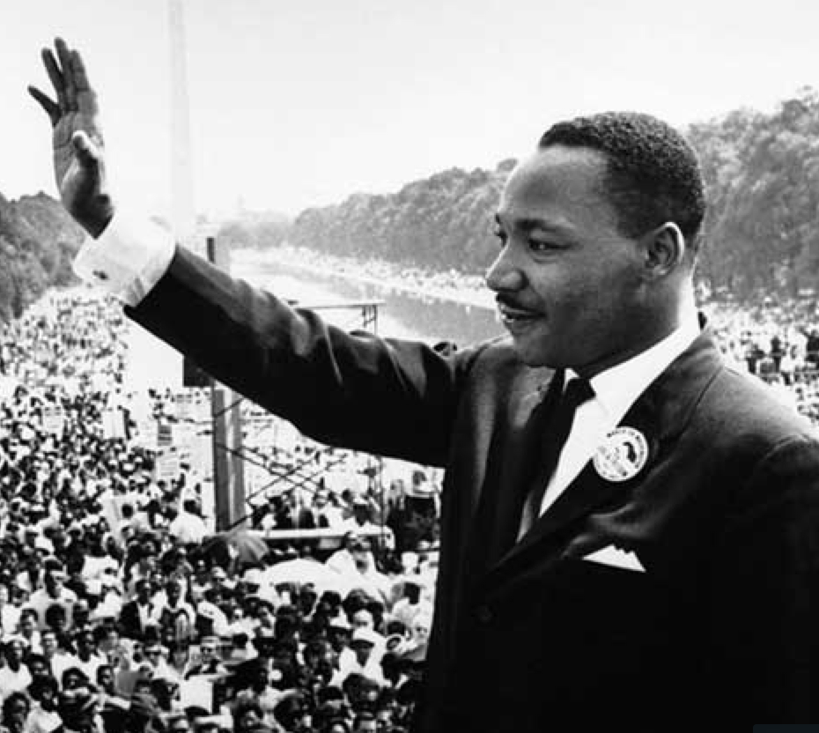  Dr. Martin Luther King, Jr. | 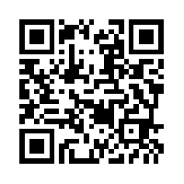
Civil Rights Collection  Thinglink | 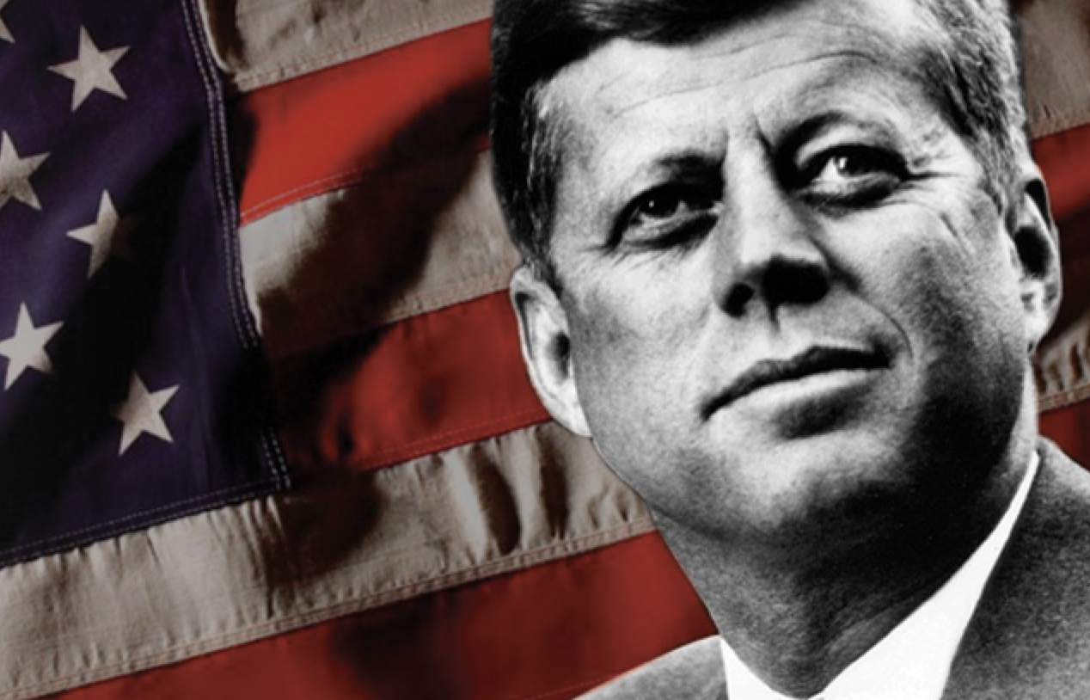  Civil Rights Collection | 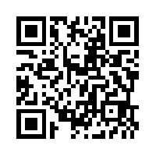
The Water Cycle  Teacher Made Activity  Thinglink | 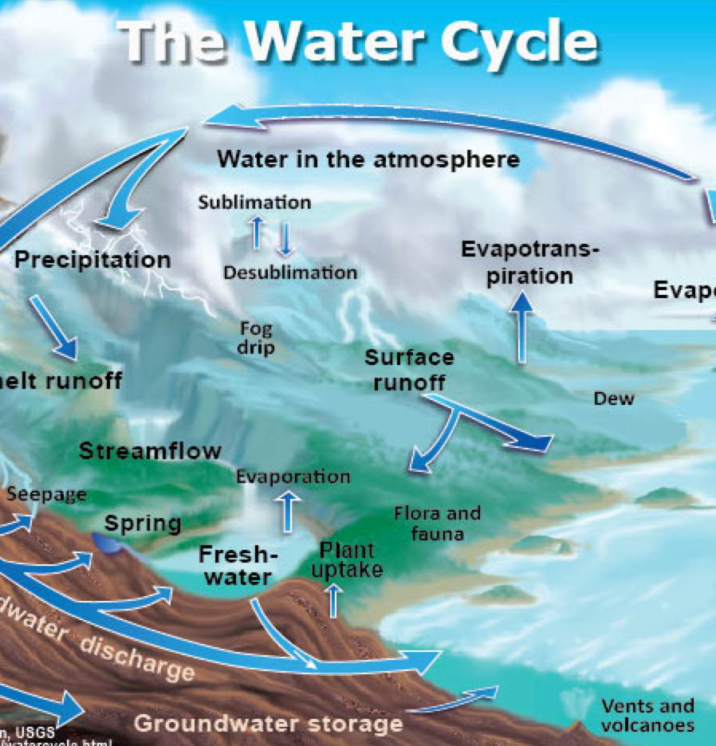  The Water Cycle | 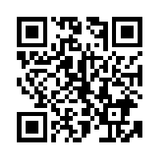
Literature Test Review  Teacher Made Activity  7th Grade LA  Thinglink | Literature Review 7th Grade | 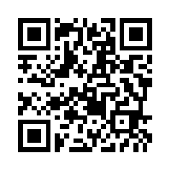
Creating Infographics  School Library Journal  A Screencast Tutorial  Showcasing  easel.ly and infogr.am | 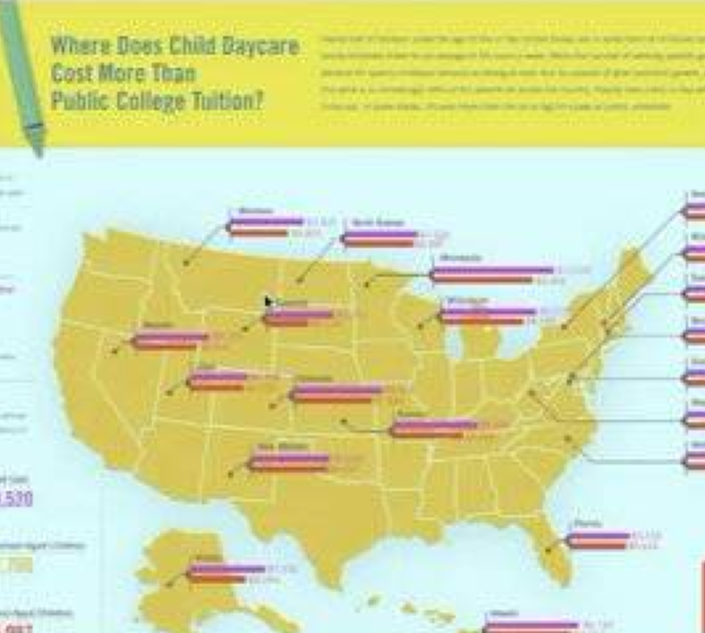  Creating Infographics | 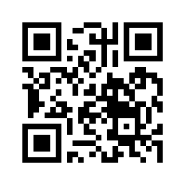
Orenchuk - August, 2014

